Contents

1.Summary 3

2. Functional Scope 3

2.1 List of features implemented 3

2.1 Browser Compatibility 23

2.2 Out of Scope 24

3. Architecture Overview 24

3.1 Context 24

3.2 High Level Architecture 24

4. Technical Specification 25

4.1 Products 25

4.1.1 Context 25

4.1.2 Constraints 25

4.1.3 Component Overview 25

4.1.4 User & Component Interactions 26

4.2 Search 27

4.2.2 Component Overview 27

4.2.3 User & Component Interactions 27

4.3 Baskets 29

4.3.1 Component Overview 29

4.3.2 User & Component Interactions 31

4.4 Checkout (Order) 38

4.4.1 Component Overview 38

4.4.2 User & Component Interactions 40

4.5 Customer 41

4.5.1 Component Overview 41

4.5.2 User & Component Interactions 42

5. Implementation Guide 42

5.1. General overview 42

5.2. Configuration 43

5.2.1. Updating cartridge path 43

5.2.2. Updating metadata 43

5.2.3. Catalog configuration 43

5.2.4. Connecting React application to SFCC 43

5.2.5. Storefront URLs 44

6. UX/UI Design 44

6.1 Design Guidelines 44

6.1.1 Buttons 45

6.1.2 Colors 46

6.1.3 Grid & Layout Principles 46

6.1.4 Iconography 47

6.1.5 Inputs 49

6.1.6 Typography System 49

6.2 Mockups 50

6.2.1 Catalog / Search Results 51

6.2.2 Checkout 53

6.2.3 Login / Registration 56

6.2.4 PDP 59

6.2.5 Shopping Cart 61

6.2.6 Showcase 67

# 1.Summary

EPAM has developed the Headless Commerce Accelerator for Salesforce Commerce Cloud. This turnkey , open source storefront application is highly customizable and allows you to create and deploy eCommerce websites faster and easier than ever before. And with a decoupled front-end architecture, edits to customer-facing websites can quickly be made without interfering with back-end development.

# 2. Functional Scope

The main functional areas implemented are:

* Product Details Page.
* Product Listing (Search) Page.
* Basket.
* Checkout.

## 2.1 List of features implemented

| **Area** | **Functional Area ID** **(WBS Code)** | **Component** | **In Scope** |
| --- | --- | --- | --- |
| Global Storefront Elements | GSE |  |  |
|  | GSE.SG | Style Guide | Y |
|  | GSE.GMP | Global Modal Popups | N |
|  | GSE.VP | Global Video Player | N |
|  | GSE.CN | Cookies Acceptance Notice | N |
|  | GSE.CRS | Global Carousel Template | N |
|  | GSE.GB | Global Background | N |
|  | GSE.BTT | Back to top button | N |
|  | GSE.PN | Phone Number Component | Y |
|  | GSE.AD | Global Accordion element | N |
|  | GSE.ANM | Global Animation | N |
|  | GSE.FV | Form Validation Framework | Y |
| Global Header | GH |  |  |
|  | GH.LG | Logo | Y |
|  | GH.NC | Header Navigation Component | Y |
|  | GH.UN | Header Utility Navigation | ? |
|  | GH.AC | Header Account Component | N |
|  | GH.SC | Header Search Field Component | N |
|  | GH.CS | Header Content Slot | N |
|  | GH.SH | Sticky Header | N |
| Global Footer | GF |  |  |
|  | GF.NC | Footer Navigation Component | Y |
|  | GF.ESF | Email Sign Up Form | N |
|  | GF.SN | Social Networking block | N |
|  | GF.CS | Footer Content Slot | N |
| Auxiliary Navigation Component | ANC |  |  |
|  | ANC.BR | Breadcrumbs | Y |
|  | ANC.PN | Pagination | Y |
|  | ANC.SPP | Show X products per page | N |
| Localization Subsystem | LCS |  |  |
|  | LCS.MCU | Multi-Currency Component | Y |
|  | LCS.MCO | Multi-Country Component | N |
|  | LCS.MLO | Multi-Locale Component | N |
| Homepage | HP |  |  |
|  | HP.HC | Hero Carousel | N |
|  | HP.REC | Product Recommendations Carousel | N |
|  | HP.CS | Home page content slots | N |
| Category Landing Page | CLP |  |  |
|  | CLP.NAV | Category Navigation | Y |
|  | CLP.CS | Category Content Slot | N |
| Product Listing Page | PLP |  |  |
|  | PLP.SWC | PLP - Layout Switcher | N |
|  | PLP.TGR | PLP - Product Tile in Grid | Y |
|  | PLP.TLI | PLP - Product Tile in List | N |
|  | PLP.NAV | PLP Refinements Navigation | Y |
|  | PLP.NR | PLP No Refinements Combination | Y |
|  | PLP.SC | PLP Sorting Component | N |
|  | PLP.CS | PLP Content Slot | N |
| Search Subsystem | SSS |  |  |
|  | SSS.SA | Search Autocomplete | N |
|  | SSS.DISP | Search Results Display | Y |
|  | SSS.PT | Search Product Tile Display | Y |
|  | SSS.PAC | Search results with products and content | N |
|  | SSS.PR | Search results with products only | Y |
|  | SSS.CNT | Search results with content only | N |
|  | SSS.VAA | View All Articles page | N |
|  | SSS.NSR | Search: No search results | N |
|  | SSS.SRB | Search Results Breadcrumbs | Y |
|  | SSS.SRN | Search Refinements Navigation | Y |
|  | SSS.SC | Search Results Sorting | N |
|  | SSS.CS | Search Results Content Slot | N |
| Recently Viewed Products Subsystem | RVP |  |  |
|  | RVP.PDP | PDP - Recently Viewed Products | N |
|  | RVP.PLP | PLP - Recently Viewed Products | N |
| Compare subsystem | CSS |  |  |
|  | CSS.CB | PLP - Compare Bucket | N |
|  | CSS.CP | Comparison Page | N |
|  | CSS.CPP | Comparison Page. Printable view | N |
| Recommendations Subsystem | REC |  |  |
|  | REC.HP | Recommendation component on Home page | N |
|  | REC.LP | Recommendation component on Listing Pages | N |
|  | REC.PDP | Recommendation component on PDP | N |
|  | REC.SC | Recommendation component on Shopping Cart | N |
|  | REC.MA | Recommendation component in My Account | N |
|  | REC.WL | Recommendation component on Wish List pages | N |
|  | REC.EM | Recommendation component in Emails | N |
| Product Subsystem | PRS |  |  |
|  | PRS.PAT | Product Attributes component | Y |
|  | PRS.PMI | Product Main Image component | Y |
|  | PRS.AV | Product Alternative views component | N |
|  | PRS.PZ | Product Image Zoom | N |
|  | PRS.VID | Product Video component | N |
|  | PRS.PP | Product Price component | Y |
|  | PRS.PV | Product Variations component | Y |
|  | PRS.PT | Product Tabs component | N |
|  | PRS.PAV | Product Availability component | Y |
|  | PRS.PB | Product Badge component | N |
|  | PRS.PQ | Product Quantity component | Y |
|  | PRS.TYPES | Product Types | Y |
|  | PRS.TYPES.STD | Standard Product | Y |
|  | PRS.TYPES.PWO | Product With Options | N |
|  | PRS.TYPES.VAR | Variation Product | Y |
|  | PRS.TYPES.BUN | Product Bundle | Y |
|  | PRS.TYPES.SET | Product Set | Y |
|  | PRS.ACT | Product Actions component | ? |
|  | PRS.ACT.ATC | PDP. Add to Cart action | Y |
|  | PRS.ACT.ATWL | PDP. Add to Wish List action | N |
|  | PRS.ACT.ATGR | PDP. Add to Gift Registry action | N |
|  | PRS.ACT.ETF | PDP. Email to a friend action | N |
|  | PRS.ACT.PR | PDP. Printable view | N |
|  | PRS.ACT.CSA | PDP. Check store availability action | N |
|  | PRS.BPS | Bonus Products Selection component | N |
|  | PRS.BPS.PDP | Bonus Products Selection on PDP | N |
|  | PRS.BPS.CART | Bonus Products Selection on Cart | N |
|  | PRS.PPN | PDP Navigation (Previous-Next) | N |
| Quick View | QV |  |  |
|  | QV.ECP | Quick View: Edit Cart popup | Y |
|  | QV.EWP | Quick View: Edit product from Wish List popup | N |
|  | QV.PPN | Quick View Navigation (Previous-Next) | N |
| Store Locator Subsystem | SLS |  |  |
|  | SLS.FRM | Store Locator - Form | N |
|  | SLS.RS | Store Locator - Results | N |
|  | SLS.NRS | Store Locator - No Results | N |
|  | SLS.SDP | Store Details popup | N |
| In-Store Pickup Subsystem | ISP |  |  |
|  | ISP.CSA | In-Store Pickup - Enter Zip Code / Select Store | N |
|  | ISP.RS | In-Store Pickup - Results | N |
|  | ISP.CART | In-Store Pickup component on Cart | N |
|  | ISP.CO | In-Store Pickup component on Checkout | N |
|  | ISP.SSP | In-Store Pickup - Single-Shipping Page | N |
|  | ISP.ORH | In-Store Pickup component on Order History page | N |
|  | ISP.ORD | In-Store Pickup component on Order Details page | N |
| Gift Cards Subsystem | GCS |  |  |
|  | GCS.ROC | Redeem Gift Certificate on checkout | N |
|  | GCS.PUR | Purchasing Gift Certificates | N |
|  | GCS.CHB | Check Gift Certificate Balance | N |
|  | GCS.ATWL | Add Gift Certificate to Wish List | N |
|  | GCS.ATGR | Add Gift Certificate to Gift Registry | N |
|  | GCS.EGC | Edit Gift Certificate from Cart | N |
| Promotions Subsystem | PROMO |  |  |
|  | PROMO.PRD | Product Level Promotions | N |
|  | PROMO.ORD | Order Level Promotions | N |
|  | PROMO.SHP | Shipping Promotions | N |
| Shopping Cart Subsystem | SCS |  |  |
|  | SCS.ITS | Cart Items | Y |
|  | SCS.EMP | Empty Cart behaviour | Y |
|  | SCS.GCS | Cart Global Slots | N |
|  | SCS.OSC | Cart. Order Summary Component | Y |
|  | SCS.CPN | Coupon Component on Cart | N |
|  | SCS.ACT | Cart. Actions | Y |
|  | SCS.ACT.IEDT | Item-level action - Edit item | Y |
|  | SCS.ACT.IRMV | Item-level action - Remove item | Y |
|  | SCS.ACT.IAWL | Item-level action - Add item to wish list | N |
|  | SCS.ACT.IAGR | Item-level action - Add item to gift registry | N |
|  | SCS.ACT.CUC | Cart-level action - Update Cart | Y |
|  | SCS.ACT.CPC | Cart-level action - Proceed to checkout | Y |
|  | SCS.ERR | Cart Errors Handling | Y |
|  | SCS.ERR.FIC | Cart - Failed Inventory Check | Y |
|  | SCS.ERR.LME | Cart - Limit Exceeded | N |
|  | SCS.MIN | Mini-Cart Container | Y |
|  | SCS.MINP | Mini-Cart with Products | Y |
|  | SCS.MINE | Mini-Cart without Products | Y |
| Checkout Subsystem | CO |  |  |
|  | CO.CF | Checkout Flows | Y |
|  | CO.CF.RCC | Returning Customer checkout | N |
|  | CO.CF.GST | Guest checkout | Y |
|  | CO.CF.REG | Register during checkout | N |
|  | CO.CF.GC | Gift Certificates Only flow | N |
|  | CO.ERR | Checkout Errors Handling | Y |
|  | CO.ERR.FIC | Checkout - Failed Inventory Check | Y |
|  | CO.ERR.LME | Checkout - Limit Exceeded | N |
|  | CO.ERR.DME | Checkout - Delivery Method Exclusions | N |
|  | CO.ERR.PE | Checkout - Payment Errors | N |
|  | CO.CAF | Checkout Authentication form | N |
|  | CO.HDR | Checkout Header | Y |
|  | CO.FTR | Checkout Footer | Y |
|  | CO.PRB | Checkout Progress Bar | N |
|  | CO.SHP | Checkout Shipping | N |
|  | CO.SHP.SSA | Single Shipping Address | Y |
|  | CO.SHP.MSA | Multiple Shipping Addresses | N |
|  | CO.SHP.SM | Checkout Shipping Method | Y |
|  | CO.GO | Checkout Gift Options | N |
|  | CO.GO.EO | Gift options for the entire order | N |
|  | CO.BIL | Checkout Billing | N |
|  | CO.BIL.BA | Checkout Billing Address | Y |
|  | CO.BIL.PM | Checkout Payment Methods | N |
|  | CO.BIL.PM.CC | Payment using Credit Card | Y |
|  | CO.BIL.PM.PP | Payment using PayPal | N |
|  | CO.BIL.PM.GC | Payment using Gift Certificate | N |
|  | CO.BIL.PM.ZSC | Payment using Zero Subtotal Checkout | N |
|  | CO.TAX | Checkout Taxation | Y |
|  | CO.SUM | Checkout Order Summary component | Y |
|  | CO.PO | Place Order | Y |
|  | CO.OR | Order Receipt | Y |
|  | CO.ORP | Order Receipt. Printable view | N |
| My Account Subsystem | MA |  |  |
|  | MA.NAV | My Account Navigation | N |
|  | MA.LGN | Login | Y |
|  | MA.RGR | Create an Account | N |
|  | MA.FGP | Forgot Password | N |
|  | MA.PWN | Set New Password | N |
|  | MA.LP | My Account Landing Page | N |
|  | MA.PD | Personal Data | N |
|  | MA.AB | Address Book | N |
|  | MA.AB.AL | Addresses List | N |
|  | MA.AB.AA | Add Address Module | N |
|  | MA.AB.EA | Edit Address Module | N |
|  | MA.PAY | Payment Methods | N |
|  | MA.PAY.ACC | Add a Credit Card | N |
|  | MA.OR | Orders Component | N |
|  | MA.OR.ORH | Order History | N |
|  | MA.OR.ORS | Order Status | N |
|  | MA.OR.ORD | Order Details | N |
|  | MA.WLC | Wish List Component | N |
|  | MA.WLS.HDR | Wish List in header | N |
|  | MA.WLS.AUF | Wish List: Authentication form | N |
|  | MA.WLS.FWL | Find Someone's Wish List | N |
|  | MA.WLS.SR | Wish List: Search Results | N |
|  | MA.WLS.WPV | Wish List Details: Public View | N |
|  | MA.WLS.WAV | Wish List Details: Account Holder`s View | N |
|  | MA.GRC | Gift Registries Component | N |
|  | MA.GRC.GH | Gift Registries in header | N |
|  | MA.GRC.AUTH | Gift Registries: Authentication form | N |
|  | MA.GRC.FS | Find Someone's Gift Registry | N |
|  | MA.GRC.SR | Gift Registry: Search Results | N |
|  | MA.GRC.PV | Gift Registry: Public View | N |
|  | MA.GRC.CR | Gift Registry: Creation | N |
|  | MA.GRC.LIST | Gift Registries list | N |
|  | MA.GRC.MRI | Manage Registry Items | N |
|  | MA.GRC.EEI | Edit Event Info | N |
|  | MA.GRC.ESI | Edit Shipping Info | N |
|  | MA.GRC.PUR | Purchases for Gift Registry | N |
| Content Pages | CP |  |  |
|  | CP.PD | Page Designer | N |
|  | CP.CS | Customer Service | N |
|  | CP.FAQ | FAQ page | N |
|  | CP.CU | Contact Us form | N |
|  | CP.PRV | Privacy Policy page | N |
|  | CP.ABU | About Us page | N |
|  | CP.TRM | Terms | N |
|  | CP.JBS | Jobs | N |
| Error pages | ERR |  |  |
|  | ERR.DIS | Errors : disabled cookies or JavaScript | N |
|  | ERR.410 | URL not found - Error 404 | N |
|  | ERR.404 | Demandware System URL Not Found | N |
|  | ERR.500 | Internal Server Error - Major Error | N |
|  | ERR.TRF | Overload Error - Heavy Traffic | N |
|  | ERR.MNT | Maintenance Page | N |
| Transactional Emails | TE |  |  |
|  | TE.HDR | Email Header | N |
|  | TE.FTR | Email Footer | N |
|  | TE.RC | Registration Confirmation | N |
|  | TE.PUN | Profile Update Notification | N |
|  | TE.PRR | Password Reset-recovery Request | N |
|  | TE.PRC | Password Reset-recovery Confirmation | N |
|  | TE.NSC | Newsletter Subscription Confirmation | N |
|  | TE.UNC | Unsubscription Confirmation | N |
|  | TE.OCF | Order Confirmation | N |
|  | TE.SC | Shipping Confirmation | N |
|  | TE.CUC | Contact Us Confirmation Mail | N |
|  | TE.GCN | Gift Certificate Notification | N |
|  | TE.BE | Backend Emails | N |
| Search Engine Optimization | SEO |  |  |
|  | SEO.CAN | Canonical URL Meta | N |
|  | SEO.PGN | Pagination Meta | N |
|  | SEO.MTD | Meta-Data | N |
|  | SEO.OG | Open Graph Meta | N |
|  | SEO.MIF | Meta Index, Follow | N |
|  | SEO.MD | Structured data Tags | N |
|  | SEO.HD | Headings | N |
|  | SEO.IAL | Images ALT Text | N |
|  | SEO.URL | URL Rules | N |
|  | SEO.RBT | Robots.txt | N |
|  | SEO.SM | Sitemap XML | N |
|  | SEO.RD | Redirects | N |
|  | SEO.PS | Page Status | N |
| Non-functional Requirements | NFR |  |  |
|  | NFR.UI | User Interface | Y |
|  | NFR.UI.COM | Accessibility | N |
|  | NFR.UI.USB | Usability | N |
|  | NFR.PER | Performance | Y |
|  | NFR.PER.BP | Backend Performance | Y |
|  | NFR.PER.CS | Client-side Performance | Y |
|  | NFR.SEC | Security | Y |
|  | NFR.SEC.COM | Compliance | Y |
|  | NFR.SEC.DP | Data Privacy | N |
|  | NFR.SEC.AP | Access Control | N |
|  | NFR.SEC.PR | User Security | N |
|  | NFR.MAI | Maintainability | Y |
|  | NFR.MAI.BAC | Backup | N |
|  | NFR.MAI.DR | Disaster Recovery | N |
|  | NFR.MAI.DAC | Data Retention | N |
|  | NFR.MAI.MON | Monitoring | N |
|  | NFR.MAI.ALR | Alerting | N |
|  | NFR.DEL | Delivery | N |
|  | NFR.DEL.DEP | Deployment | N |
|  | NFR.DEL.IMP | Implementation | ? |
|  | NFR.DEL.CS | Code Standards | Y |
|  | NFR.DEL.DC | Documentation | Y |
|  | NFR.INF | Infrastructure | Y |
|  | NFR.INF.AE | Application Environment | Y |
|  | NFR.INF.DNS | Domains - DNS | N |
|  | NFR.INF.SFTP | File Exchange - SFTP | N |
|  | NFR.INF.SSL | Security Protocols - SSL | Y |
|  | NFR.CMP | Compatibility | Y |
|  | NFR.CMP.BR | Browsers & Devices | N |
|  | NFR.CMP.EM | Email Clients | N |
|  | NFR.TST | Testability | Y |
|  | NFR.TST.AT | Automated Functional Testing | N |
|  | NFR.TST.UT | Unit Testing | Y |
|  | NFR.TST.MT | Manual Testing | Y |
|  | NFR.TST.PT | Penetration testing | N |
|  | NFR.TST.LT | Load Testing | N |
|  | NFR.CON | Configurability | Y |
|  | NFR.CON.SS | Sites Setup | N |
|  | NFR.CON.PS | Pricebooks Setup | N |
|  | NFR.CON.IL | Inventory Lists Setup | N |
|  | NFR.CON.CS | Catalogs Setup | N |
|  | NFR.CON.TS | Taxation Setup | N |
|  | NFR.CON.CL | Customer Lists Setup | N |
|  | NFR.CON.CC | Content Configuration | N |
|  | NFR.MGR | Data Migration | N |
|  | NFR.MGR.ORD | Historical order migration | N |
|  | NFR.MGR.CUS | Customers Migration | N |
|  | NFR.MGR.IMI | Product data migration | N |
|  | NFR.MGR.INV | Inventory data migration | N |
|  | NFR.MGR.PBI | Price book migration | N |
|  | NFR.MGR.GC | Gift Certificates migration | N |
| Third party integrations | 3PI |  |  |
|  | 3PI.PIM | PIM Integration | N |
|  | 3PI.PIM.{PIM_ID} | {PIM_NAME} | N |
|  | 3PI.PIM.{PIM_ID}.NCI | Navigation Catalog Import | N |
|  | 3PI.PIM.{PIM_ID}.PMI | Product Master Data Import | N |
|  | 3PI.PIM.{PIM_ID}.PCI | Product to Categories Assignments Import | N |
|  | 3PI.PIM.{PIM_ID}.PMI | Product Images Import | N |
|  | 3PI.ERP | ERP Integration | N |
|  | 3PI.ERP.{ERP_ID} | {ERP_NAME} | N |
|  | 3PI.ERP.{ERP_ID}.IVI | Inventory Import | N |
|  | 3PI.ERP.{ERP_ID}.LIL | Live Inventory Lookup | N |
|  | 3PI.ERP.{ERP_ID}.PBI | Pricebook Import | N |
|  | 3PI.ERP.{ERP_ID}.OE | Order Export | N |
|  | 3PI.ERP.{ERP_ID}.OSI | Order Shipping Update Import | N |
|  | 3PI.ERP.{ERP_ID}.ORI | Order Return Update Import | N |
|  | 3PI.ERP.{ERP_ID}.OSU | Order Status Update Import | N |
|  | 3PI.ERP.{ERP_ID}.IVO | Invoice/Credit Notes Import | N |
|  | 3PI.ERP.{ERP_ID}.RC | Refund Confirmation Feed | N |
|  | 3PI.CRM | CRM System | N |
|  | 3PI.CRM.{CRM_ID} | {CRM_NAME} | N |
|  | 3PI.CRM.{CRM_ID}.CUE | Customer data export | N |
|  | 3PI.CRM.{CRM_ID}.CUI | Customer data Import | N |
|  | 3PI.OMS | OMS Integration | N |
|  | 3PI.OMS.{OMS_ID} | {OMS_NAME} | N |
|  | 3PI.OMS.{OMS_ID}.IVI | Inventory Import | N |
|  | 3PI.OMS.{OMS_ID}.LIL | Live Inventory Lookup Call | N |
|  | 3PI.OMS.{OMS_ID}.PBI | Pricebook Import | N |
|  | 3PI.OMS.{OMS_ID}.OE | Order Export | N |
|  | 3PI.OMS.{OMS_ID}.OH | Order History Call | N |
|  | 3PI.OMS.{OMS_ID}.OD | Order Details Call | N |
|  | 3PI.OMS.{OMS_ID}.IR | Inventory Reservation API Call | N |
|  | 3PI.OMS.{OMS_ID}.IRC | Inventory Reservation Cancellation API Call | N |
| Project Requirements | PRR |  |  |
|  | PRR.TOO | Project Tools | Y |
|  | PRR.TOO.JIR | Jira | Y |
|  | PRR.TOO.CON | Confluence | Y |
|  | PRR.TRI | Project Training | N |
|  | PRR.TRI.PLA | SFCC platform training | N |
|  | PRR.TRI.3PL | 3rd party training | N |
|  | PRR.TRI.DOC | Project documentation | Y |
|  | PRR.PRJ | Project Approach | Y |
|  | PRR.PRJ.PJM | Project Management | Y |
|  | PRR.PRJ.ENG | Project Engagement | N |
|  | PRR.PRJ.CON | Content Management | N |
|  | PRR.PRJ.SEO | SEO Management | N |
|  | PRR.PRJ.UXI | UX and UI | Y |

## 2.1 Browser Compatibility

The following browsers will be supported:

* Chrome 83
* Safari 13.1
* Firefox 76

## 2.2 Out of Scope

* Accessibility.
* Responsive web design.

# 3. Architecture Overview

## 3.1 Context

The system consists of business logic (process) APIs implemented by Storefront Reference Architecture (SFRA) extensions and a decoupled front-end implemented in React. The SFRA was leveraged to significantly minimize the business logic development effort and take advantage of the ease to convert the SFRA view model into JSON responses.

## 3.2 High Level Architecture

Note there is no authentication service in the original implementation and the APIs are neither stateless nor RESTful. The implementation of a Customer Experience API (API Management) is out of scope.

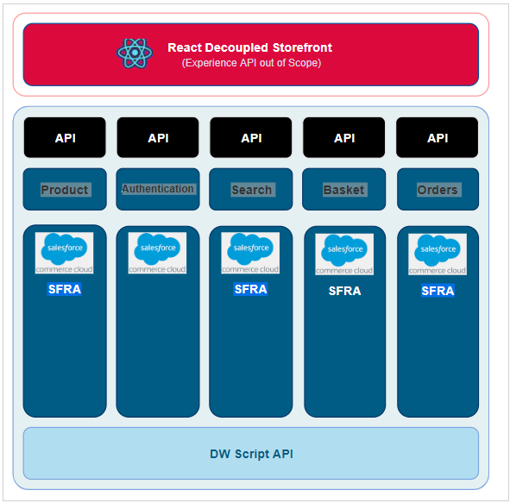

# 4. Technical Specification

This section describes the high-level front end (React) component decomposition and the component interfaces.

## 4.1 Products

### 4.1.1 Context

Product information is required for the product details page, product listing (search) page, basket, minibasket and orders (product line items).

### 4.1.2 Constraints

The product data returned by the APIs are quite large and in a number of cases, the frontend layer is over fetching data, we should consider using GraphQL to address the problem. The APIs do not adhere to REST principles as we are using SFRA controllers for data requests.

### 4.1.3 Component Overview

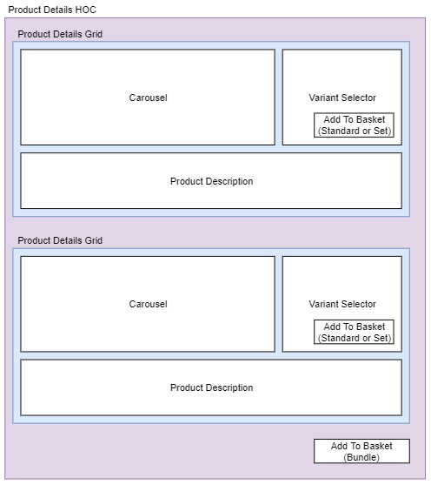

### 4.1.4 User & Component Interactions

**View Product**

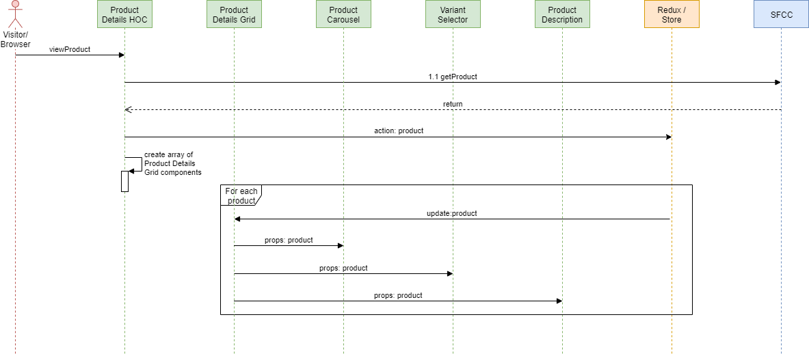

|  |  |
| --- | --- |
|  | **Interface Specification** |
| 1.1 getProduct | [PROD01-ViewProduct](https://kb.epam.com/display/EPMCSHDL/Products" \l "Products-PROD01-ViewProduct)  Note there are three response types accounting for standard products, product sets and product bundles. |

**Select Variant**

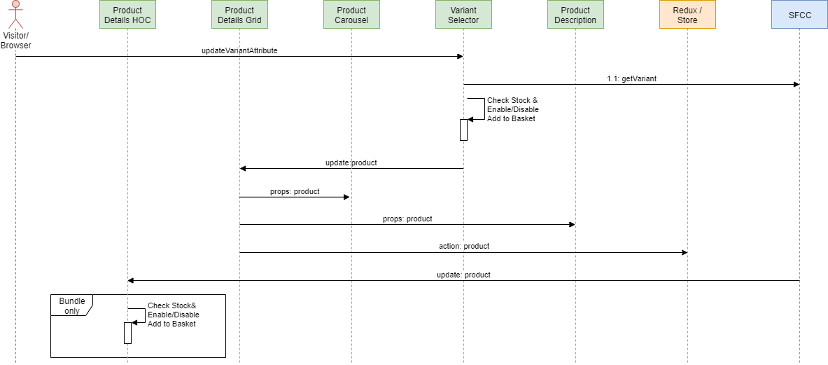

|  |  |
| --- | --- |
|  | **Interface Specification** |
| 1.1 getVariant | [PROD03-ViewProductVariation](https://kb.epam.com/display/EPMCSHDL/Products#Products-PROD03-ViewProductVariation)  Note there are three response types accounting for standard products, product sets and product bundles. |

## 4.2 Search

### 4.2.2 Component Overview

This section describes the functional decomposition of product listing page and category landing page elements and their configuration.

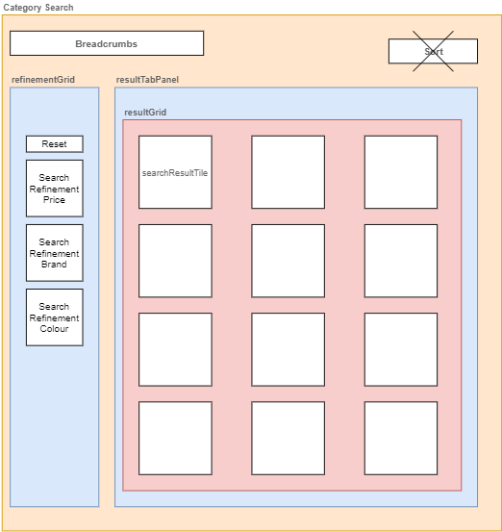

### 4.2.3 User & Component Interactions

Search APIs support the following customer experience:

* Browse product catalogue (categories)
* Search result refinement (filters)

**Browse Product Catalogue**

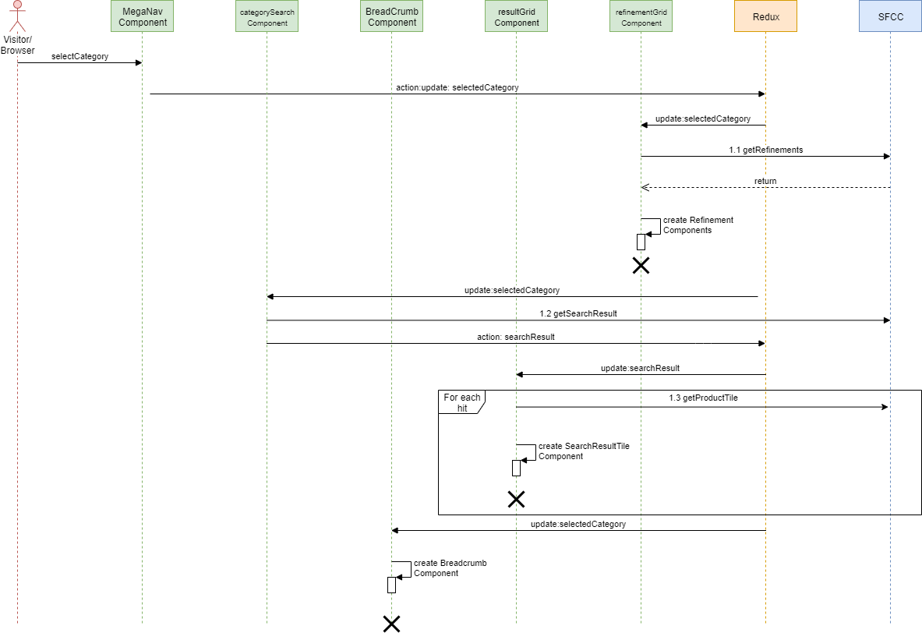

|  |  |
| --- | --- |
|  | **Interface** |
| 1.1 | [SRCH01](https://kb.epam.com/display/EPMCSHDL/Search#Search-srch01searchbycategory)- Search by category request and result response excluding refinement options. |
| 1.2 | [SRCH02](https://kb.epam.com/display/EPMCSHDL/Search#Search-srch02searchbyrefinement) - Search refinement definition for a given category and refinement selection. Response includes search result (of products). |
| 1.3 | [PROD02](https://kb.epam.com/display/EPMCSHDL/Products#Products-prod02producttile) - Product Tile |

**Search Result Refinements (filters)**

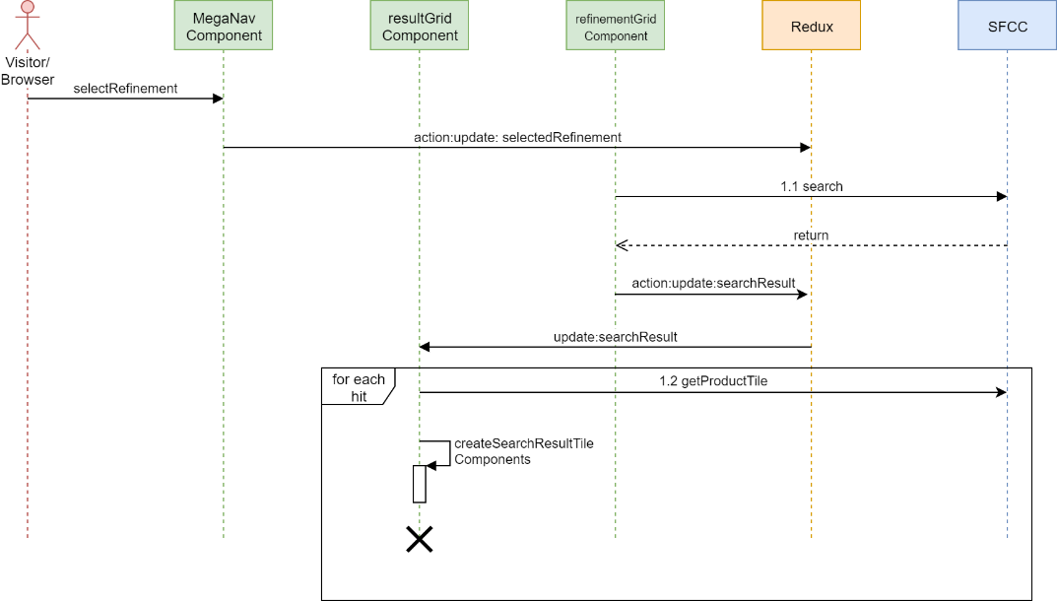

|  |  |
| --- | --- |
|  | **Interface** |
| 1.1 | [SRCH02](https://kb.epam.com/display/EPMCSHDL/Search#Search-srch02searchbyrefinement) - Search refinement definition for a given category and refinement selection. Response includes search result (of products). |

## 4.3 Baskets

This section defines the components required for the implementation of the minibasket and the main basket page both when empty and with line items.

### 4.3.1 Component Overview

**Mini Basket**

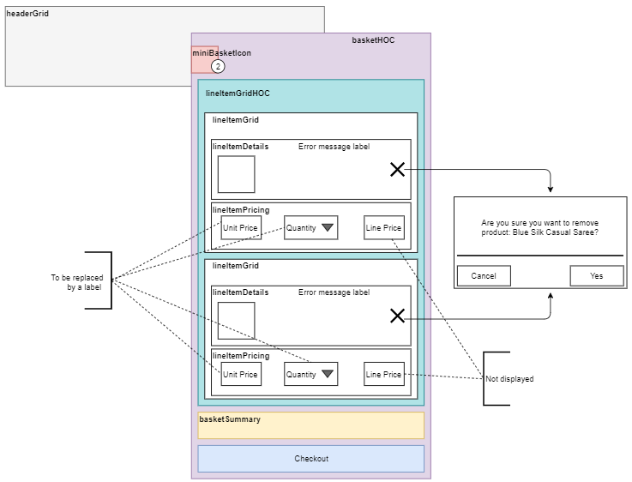

**Main Basket**

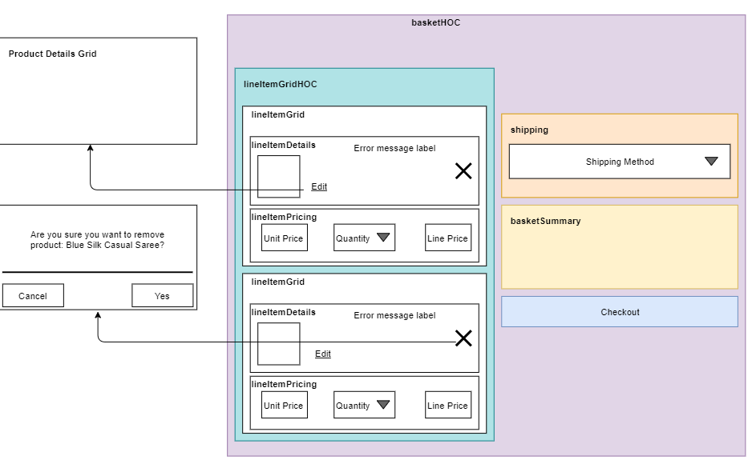

### 4.3.2 User & Component Interactions

**Common Business Logic**

The Add to Basket button should be enabled if the following conditions are met:

* The product is available to sell (product.available === true).
* All product attributes are selected (product.readyToOrder === true)

Specify product.id in the AddProductToBasket interface.

Note that product options are out of scope and the options array should be left blank.

**View Mini Basket**

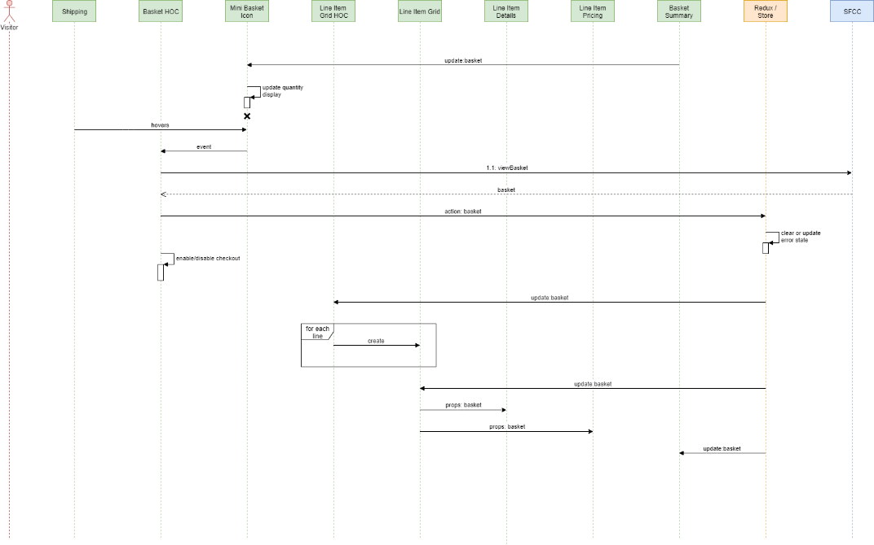

|  |  |
| --- | --- |
|  | **Interfaces** |
| 1.1 viewMiniBasket | [BSKT01-ViewBasket](https://kb.epam.com/display/EPMCSHDL/Basket#Basket-BSKT01-ViewBasket) |

**View Main Basket**

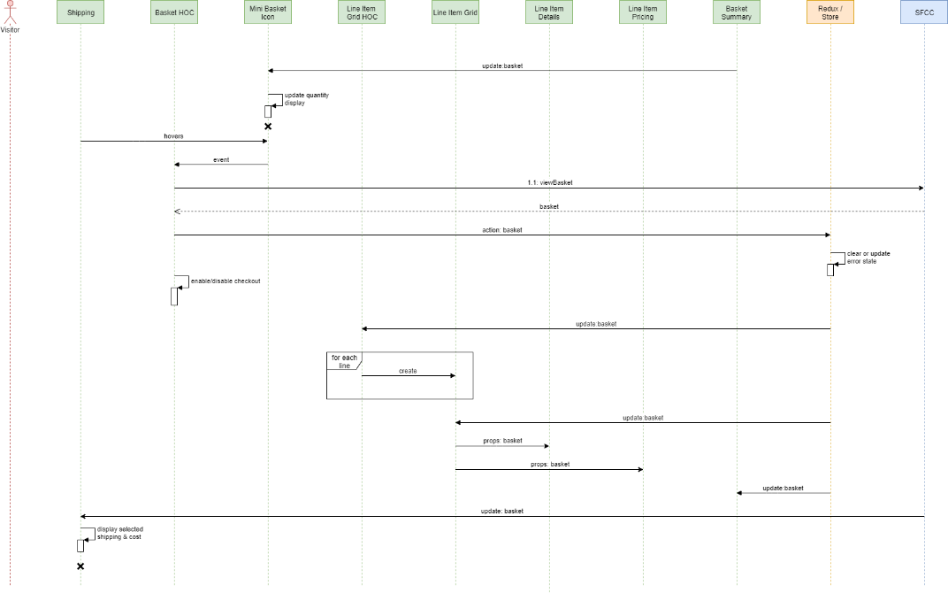

|  |  |
| --- | --- |
|  | **Interfaces** |
| 1.1 viewMiniBasket | [BSKT01-ViewBasket](https://kb.epam.com/display/EPMCSHDL/Basket#Basket-BSKT01-ViewBasket) |

**Update Shipping Method**

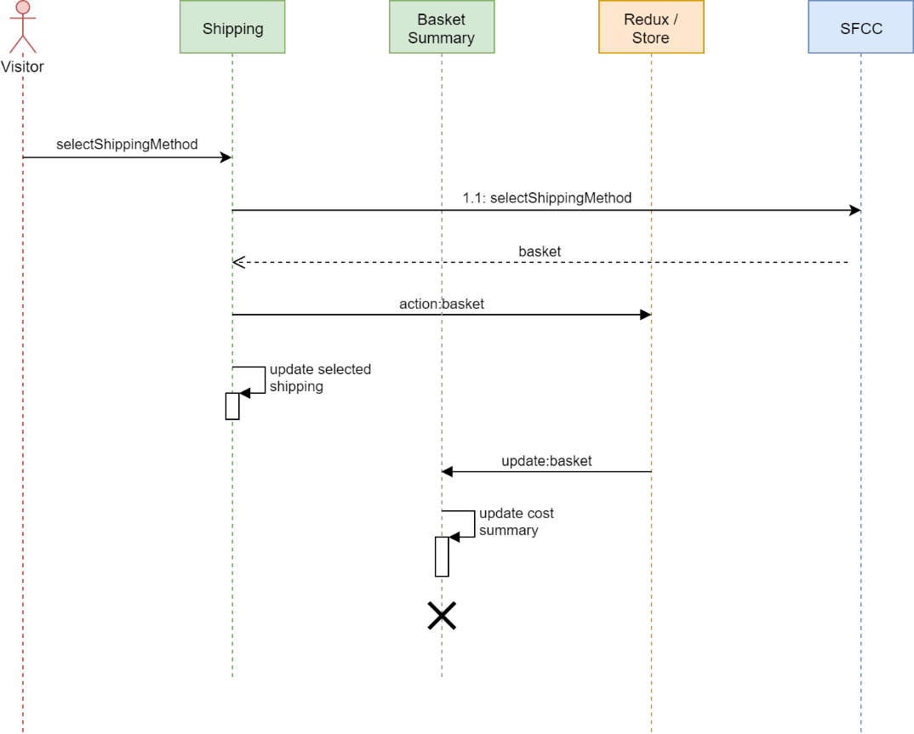

|  |  |
| --- | --- |
|  | **Interfaces** |
| 1.1 viewMiniBasket | [BSKT05-SelectShippingMethod](https://kb.epam.com/display/EPMCSHDL/Basket#Basket-BSKT05-SelectShippingMethod) |

**Update Shipping Address**

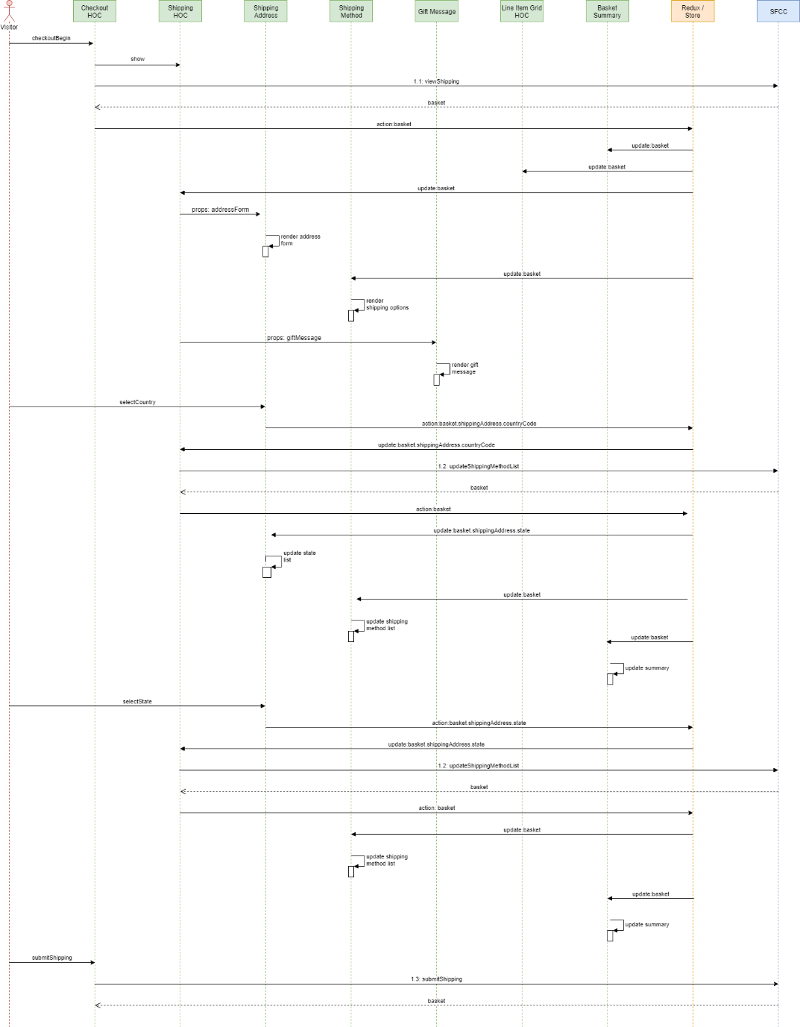

|  | **Interfaces** |
| --- | --- |
| 1.1 viewShipping | [BSKT06-Checkout](https://kb.epam.com/display/EPMCSHDL/Basket#Basket-BSKT06-Checkout) |
| 1.2 updateShippingMethodList | [BSKT07-UpdateShippingMethod](https://kb.epam.com/display/EPMCSHDL/Basket#Basket-BSKT07-UpdateShippingMethod) |
| 1.3 submitShipping | [BSKT08-UpdateShipment](https://kb.epam.com/display/EPMCSHDL/Basket#Basket-BSKT08-UpdateShipment) |

**Add Product to Basket**

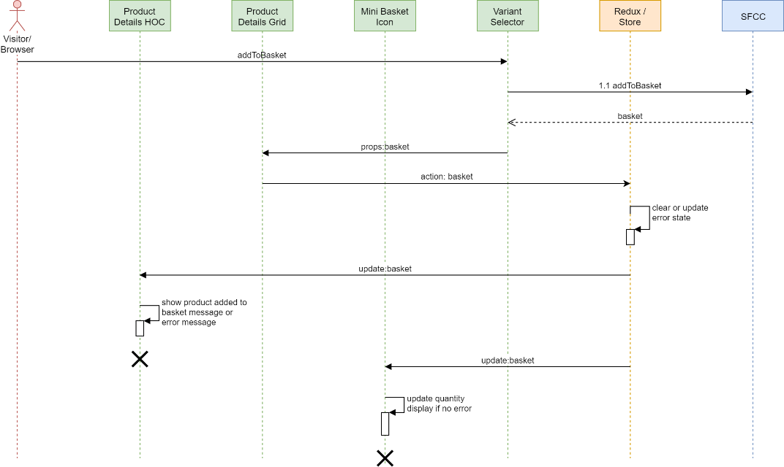

|  |  |
| --- | --- |
|  | **Interfaces** |
| 1.1 addToBasket | [BSKT02-AddProducttoBasket](https://kb.epam.com/display/EPMCSHDL/Basket#Basket-BSKT02-AddProducttoBasket)  Adds a single product to basket |

**Add all Products to Basket (Product Set)**

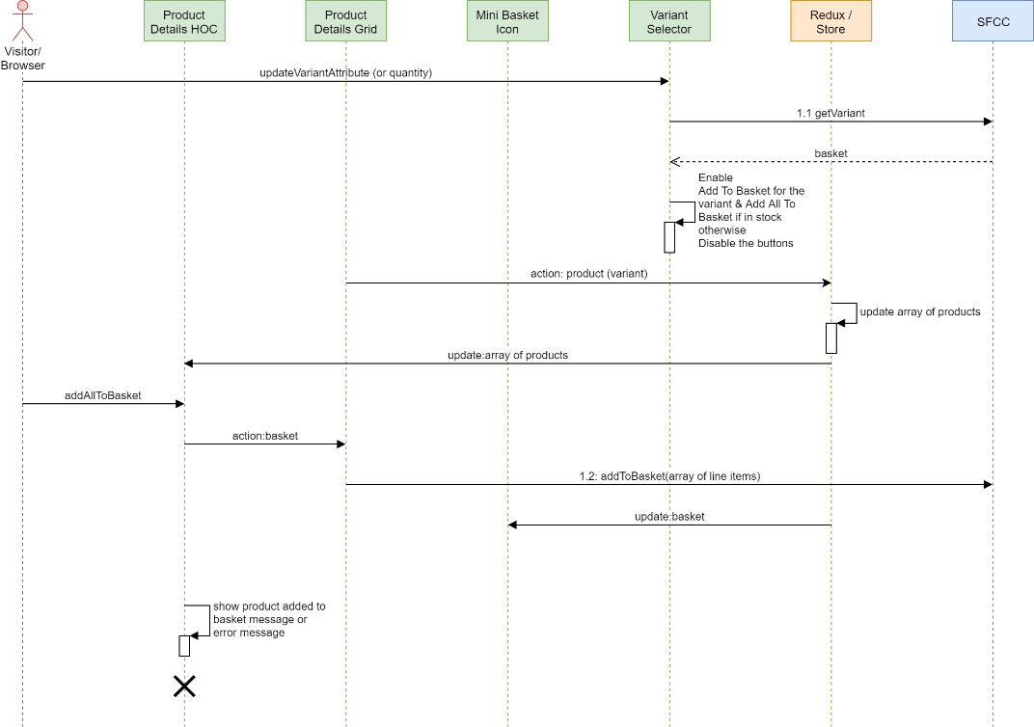

|  |  |
| --- | --- |
|  | **Interfaces** |
| 1.1 getVariant | [Products#PROD03-ViewProductVariation](https://kb.epam.com/display/EPMCSHDL/Products#Products-PROD03-ViewProductVariation) |
| 1.2 addToBasket | [BSKT02-AddProducttoBasket](https://kb.epam.com/display/EPMCSHDL/Basket#Basket-BSKT02-AddProducttoBasket)  (Note an array of all products in the set should be added to the basket in one service call) |

**Add Product to Basket - Product Bundle**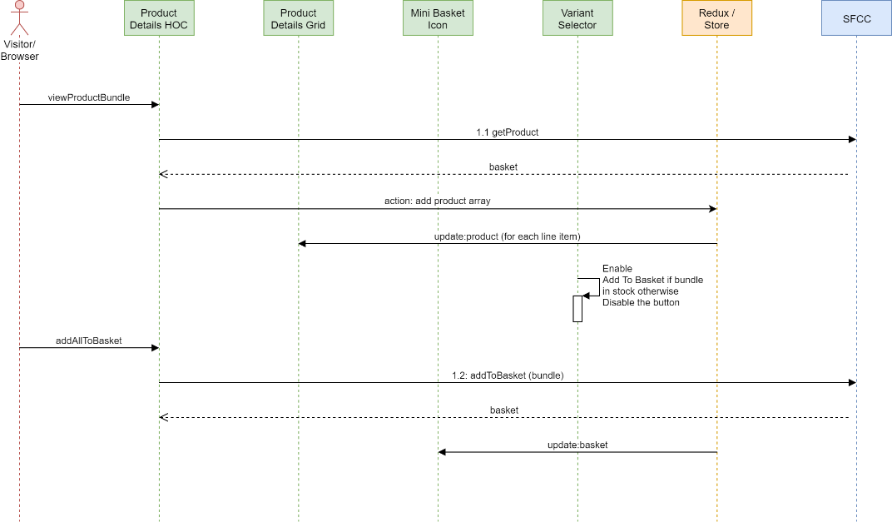

|  |  |
| --- | --- |
|  | **Interfaces** |
| 1.1 getVariant | [Products#PROD01-ViewProduct](https://kb.epam.com/display/EPMCSHDL/Products#Products-PROD01-ViewProduct) |
| 1.2 addToBasket | [BSKT02-AddProducttoBasket](https://kb.epam.com/display/EPMCSHDL/Basket#Basket-BSKT02-AddProducttoBasket) |

**Remove Product from Basket**

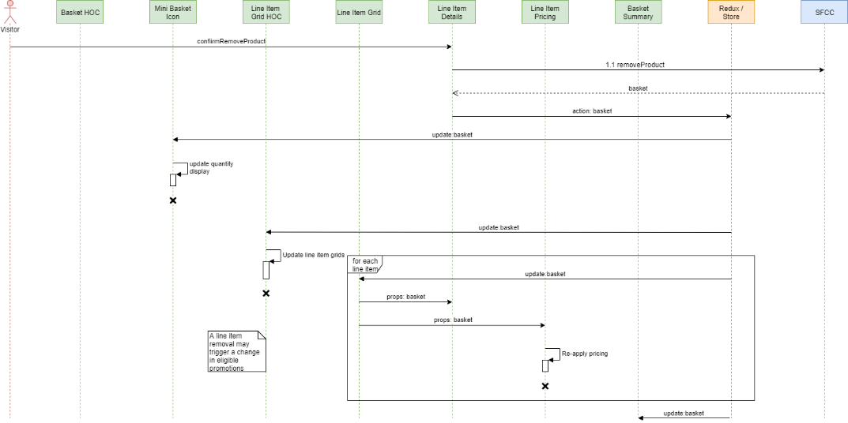

|  |  |
| --- | --- |
|  | **Interfaces** |
| 1.1 removeProduct | [BSKT03-RemoveProductfromBasket](https://kb.epam.com/display/EPMCSHDL/Basket#Basket-BSKT03-RemoveProductfromBasket) |

**Update Basket Line Item Quantity**

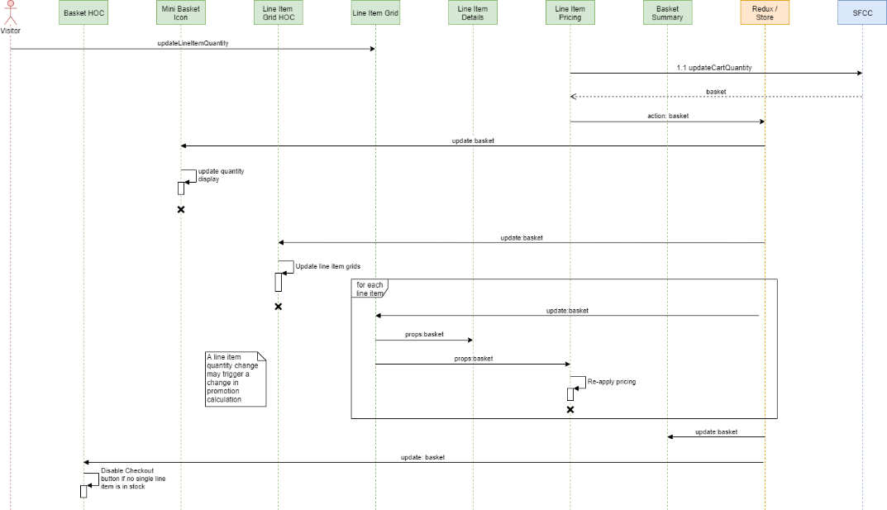

|  |  |
| --- | --- |
|  | **Interfaces** |
| 1.1 updateCartQuantity | [BSKT04-UpdateLineItemQuantity](https://kb.epam.com/display/EPMCSHDL/Basket#Basket-BSKT04-UpdateLineItemQuantity) |

## 4.4 Checkout (Order)

### 4.4.1 Component Overview

This section defines the components required for the implementation of payments, order review and confirmation pages.

**Shipping Stage**

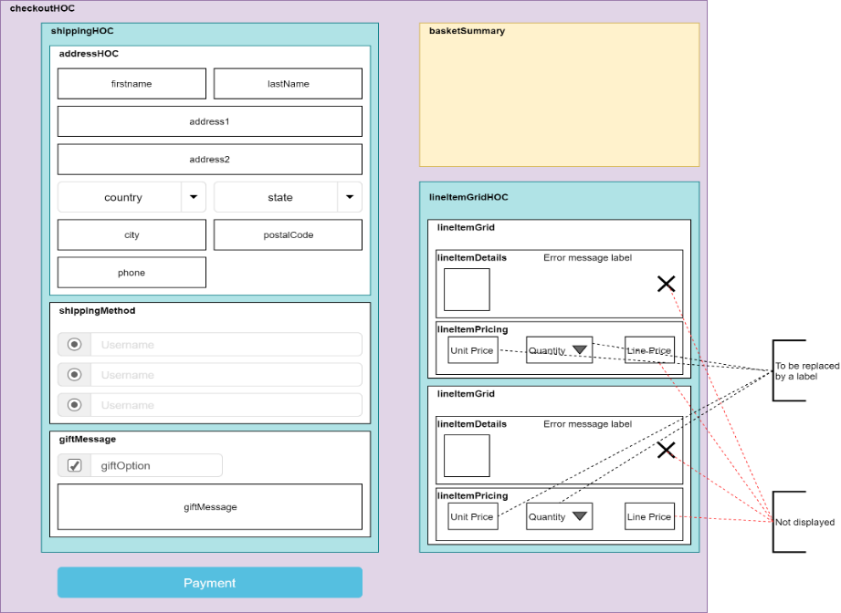

**Payments Stage**

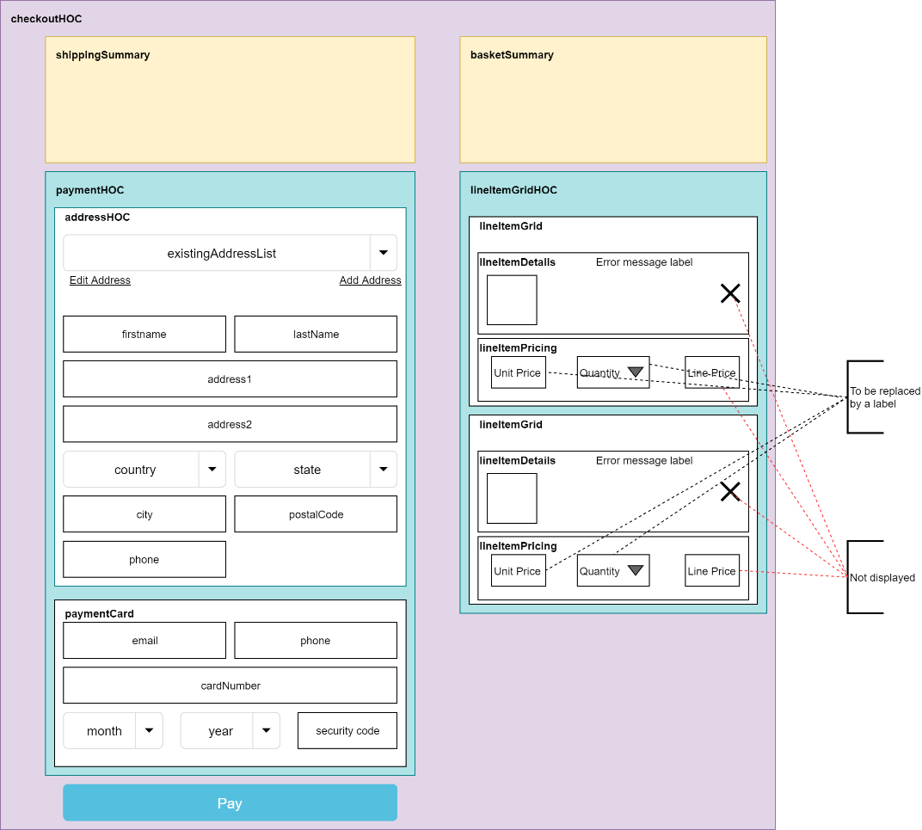

**Place Order Stage**

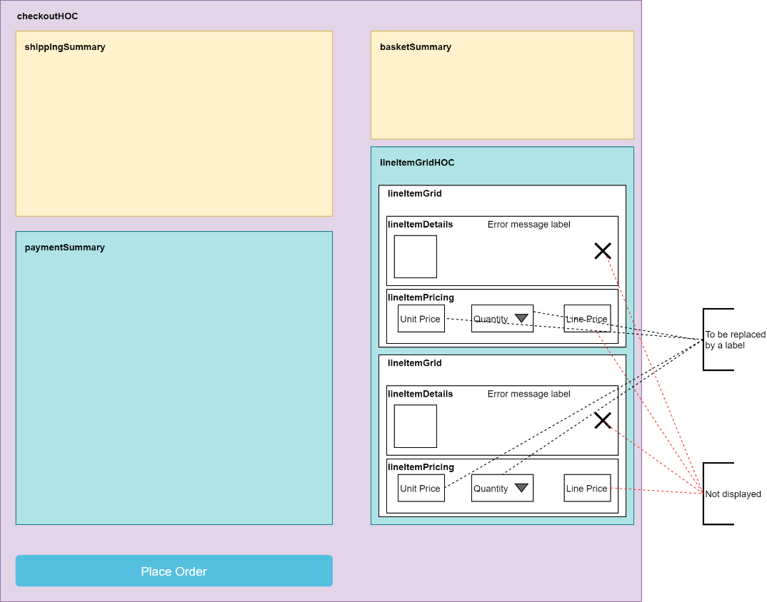

**Order Confirmation**

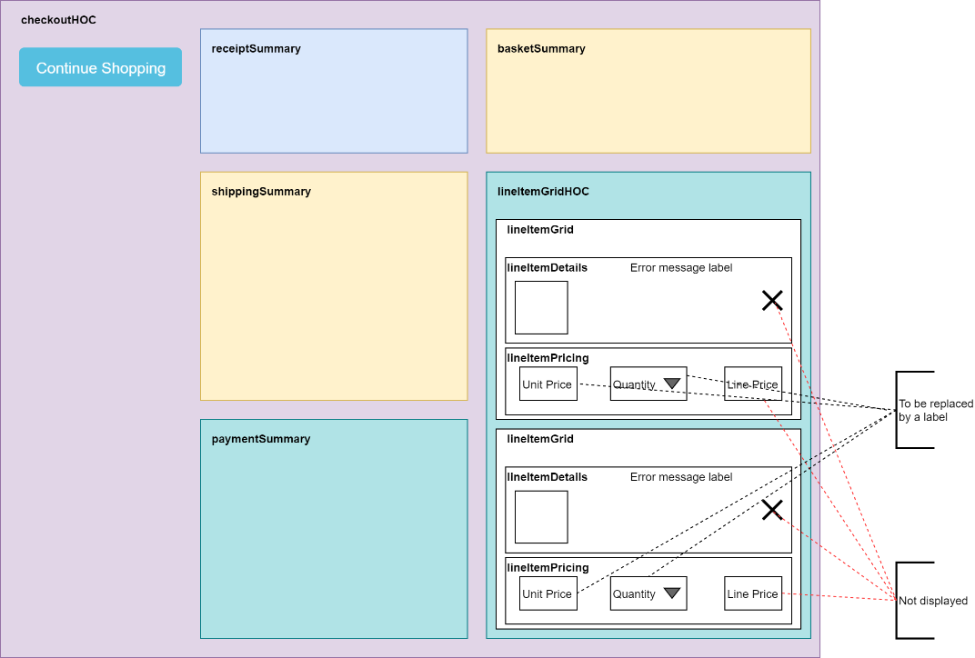

### 4.4.2 User & Component Interactions

**Update Payment**

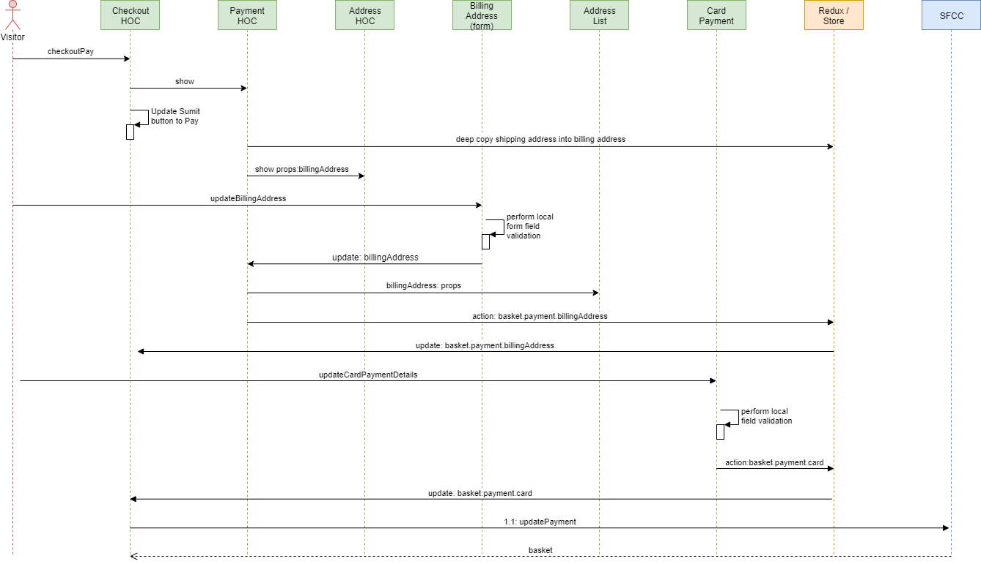

|  | **Interfaces** |
| --- | --- |
| 1.1 updatePayment | [ORD01-UpdatePayment](https://kb.epam.com/display/EPMCSHDL/Order#Order-ORD01-UpdatePayment) |

**Order Place**

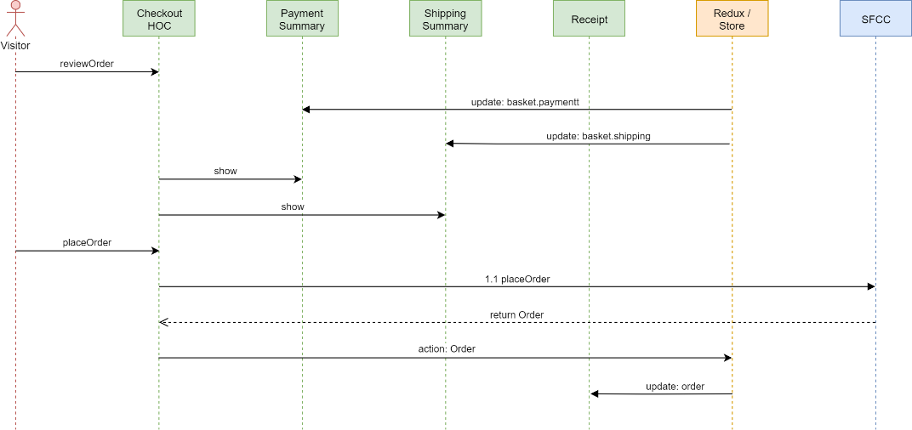

|  | **Interfaces** |
| --- | --- |
| 1.1 placeOrder | [ORD02-PlaceOrder](https://kb.epam.com/display/EPMCSHDL/Order#Order-ORD02-PlaceOrder) |

## 4.5 Customer

### 4.5.1 Component Overview

This section defines the components required for the implementation of customer registration, login and my account components.

**Checkout Login**

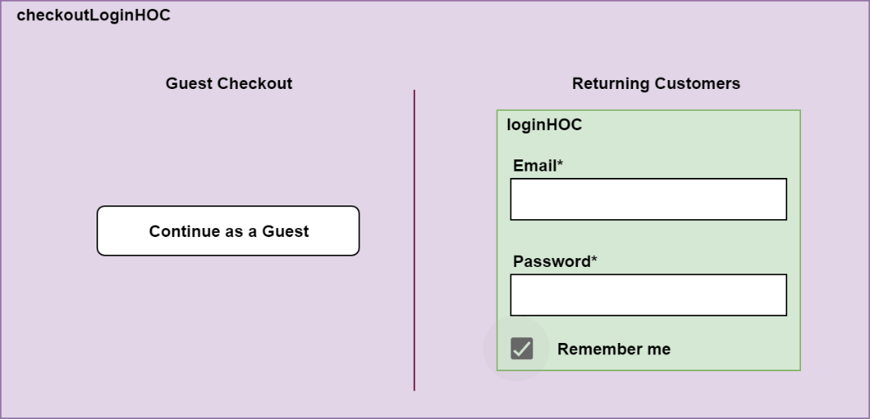

### 4.5.2 User & Component Interactions

**Identification**

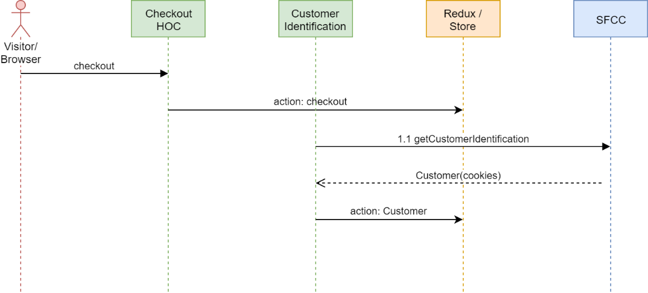

**Checkout**

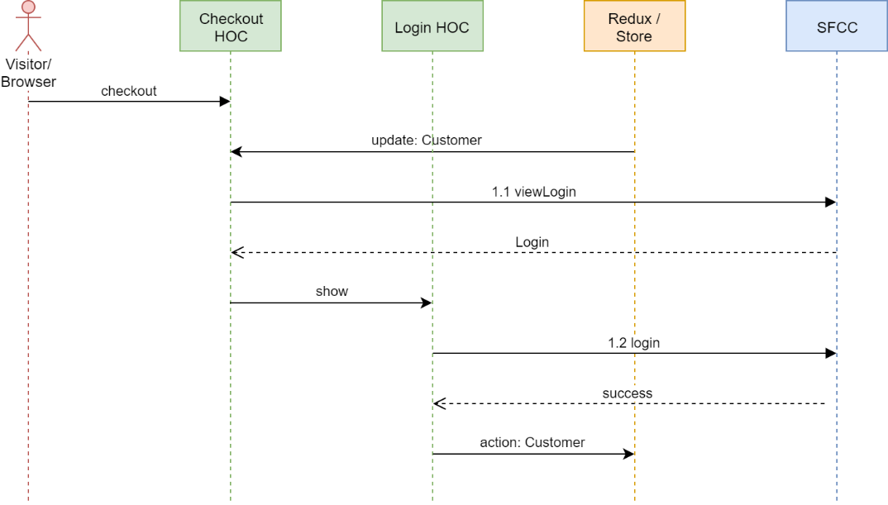

# 5. Implementation Guide

## 5.1. General overview

This implementation consists of 3 parts and divided into three folders:

* **process_api** – folder which contains *app_storefront_custom* cartridge which extends SFRA functionality to make possible communication between react application and Salesforce Commerce Cloud
* **react-app** – contains code for frontend part of the application
* **storefrontdata-master** – metadata needed to extend existing initial SFRA metadata

## 5.2. Configuration

To make a react application ready to work you need to do some configuration.

## 5.2.1. Updating cartridge path

To integrate headless SFRA based on React.js you need to add *app_storefront_custom* to your target site cartridge path before base SFRA cartridges. In order to add cartridge to cartridge path: **BM > Administration > Sites > Manage Sites > <YOUR SITE> - Settings > Cartridges:**

app_storefront_custom:app_storefront_base:modules

## 5.2.2. Updating metadata

In order to adopt react application to SFRA you need to update metadata. Metadata are provided in a special folder: *storefrontdata-master*. In order to update metadata, go to: **Administration > Site Development > Import & Export:** upload **system-objecttype-extensions.xml** and import it

## 5.2.3. Catalog configuration

You need to configure categories: by enabling **isPLP** custom attribute on every category in site catalog where it is needed. It means that for categories where **isPLP** is disabled product grid won’t be shown.

Optionally, you can adopt existing demo SFRA catalog you can import demo storefront catalog under **storefront-catalog-m-en.** In order to import demo configuration, go to: **Merchant Tools > Products and Catalogs > Import & Export** upload demo storefront catalog and import it

## 5.2.4. Connecting React application to SFCC

In order to connect react application to SFCC in your file system go to **react-app/.env** and specify base url of your storefront. Please look at example below:

NODE_PATH=src/

HTTPS=true

REACT_APP_BASE_URL=https://zzrp-005.sandbox.us01.dx.commercecloud.salesforce.com/on/demandware.store/Sites-RefArch-Site/en_US

You need to configure api.js: **react-app/src/services/config** as example below:

const api = {

  host: "https://zzrp-005.sandbox.us01.dx.commercecloud.salesforce.com",

};

export default api;

## 5.2.5. Storefront URLs

New Rule-Based Storefront URLs should be disabled to avoid communication issues between react app and SFCC. In order to disable storefront URLs in BM go to: **Merchant Tools > Site Preferences > Storefront URL** and uncheck **Enable Storefront URLs:**

# 6. UX/UI Design

## 6.1 Design Guidelines

The Design Guide is a single source of truth and set of deliverables which gives a possibility to design and develop the digital product.

Design Guide includes design patterns, principles and components.

The goals of the Design Guide include improving UI consistency and making the design and development process more efficient and focused.

**Design Tool:** [Figma](https://www.figma.com/)

**React Framework:** [Material UI](https://material-ui.com/)

**Design Sources:** [Click to open source](https://www.figma.com/file/7yNiT4UIlCFrzICq5FmBp3/EPMC-SHDL?node-id=252%3A672)

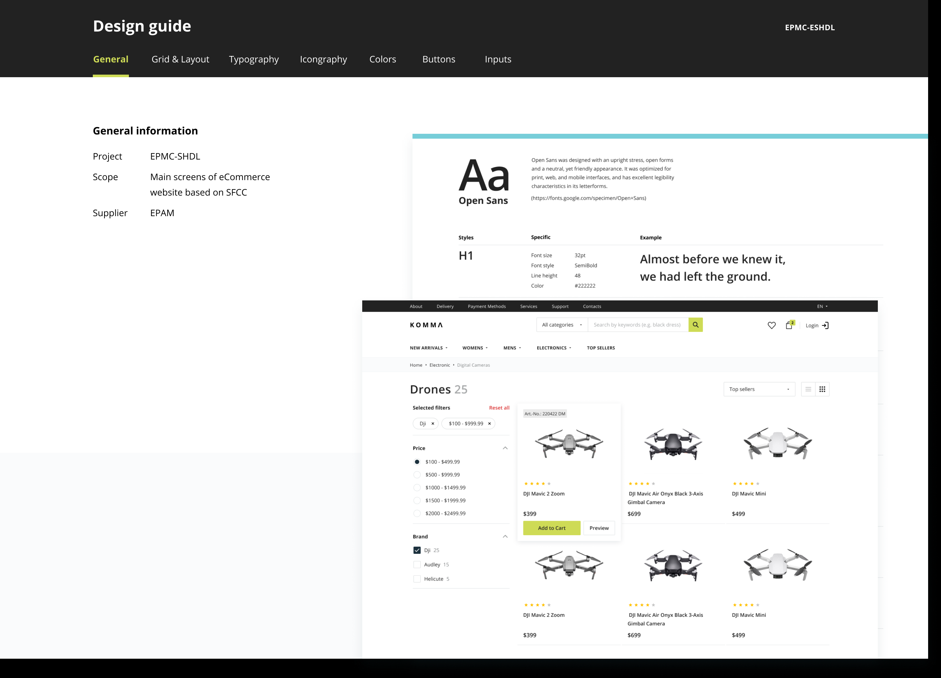

### 6.1.1 Buttons

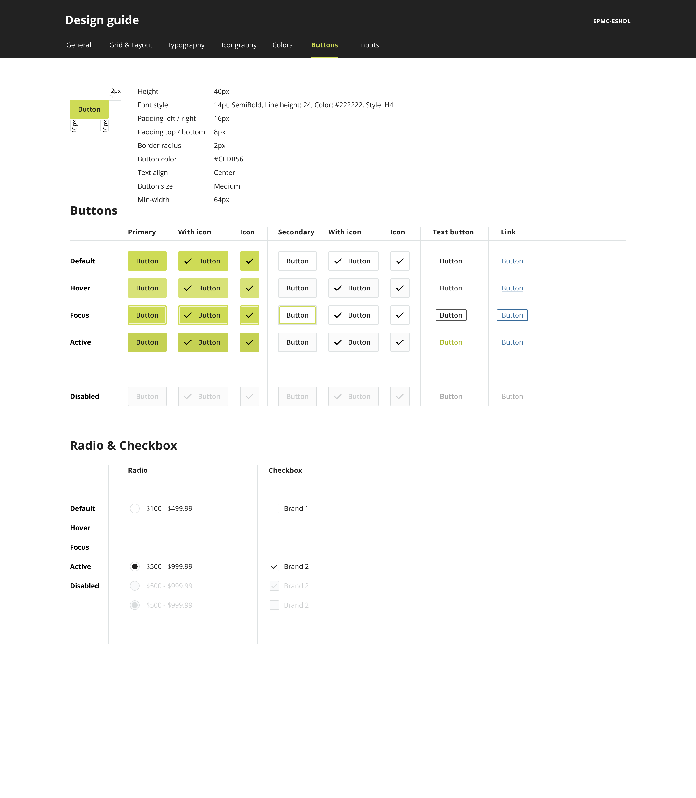

### 6.1.2 Colors

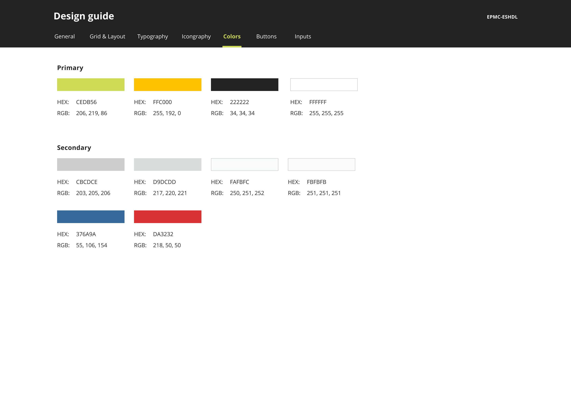

### 6.1.3 Grid & Layout Principles

Grid and layout principles were designed to keep consistency through the website, define the basic component and content positioning.

In addition, it provides scalable layout behavior in terms of responsiveness.

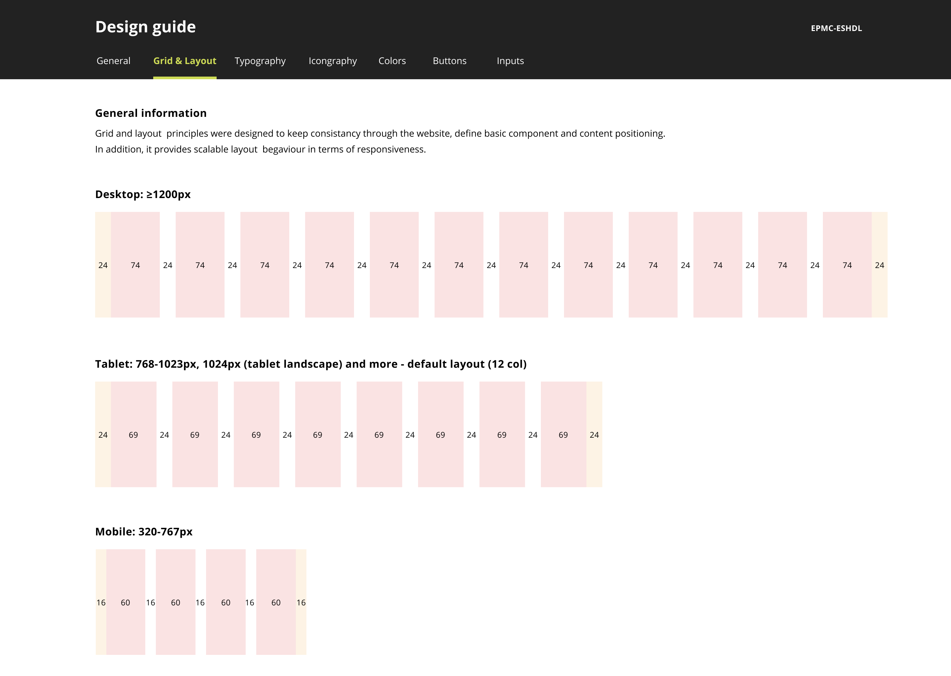

### 6.1.4 Iconography

An icon is a visual representation of system actions. Icons provide additional context for users to enhance the usability of a User Interface.

Regular icons are designed on a 20px aria and placed on a 24px artboad.

Icon style has two option: filled and outlined. Use icon style depends on the context. Keep in mind that the main style is outline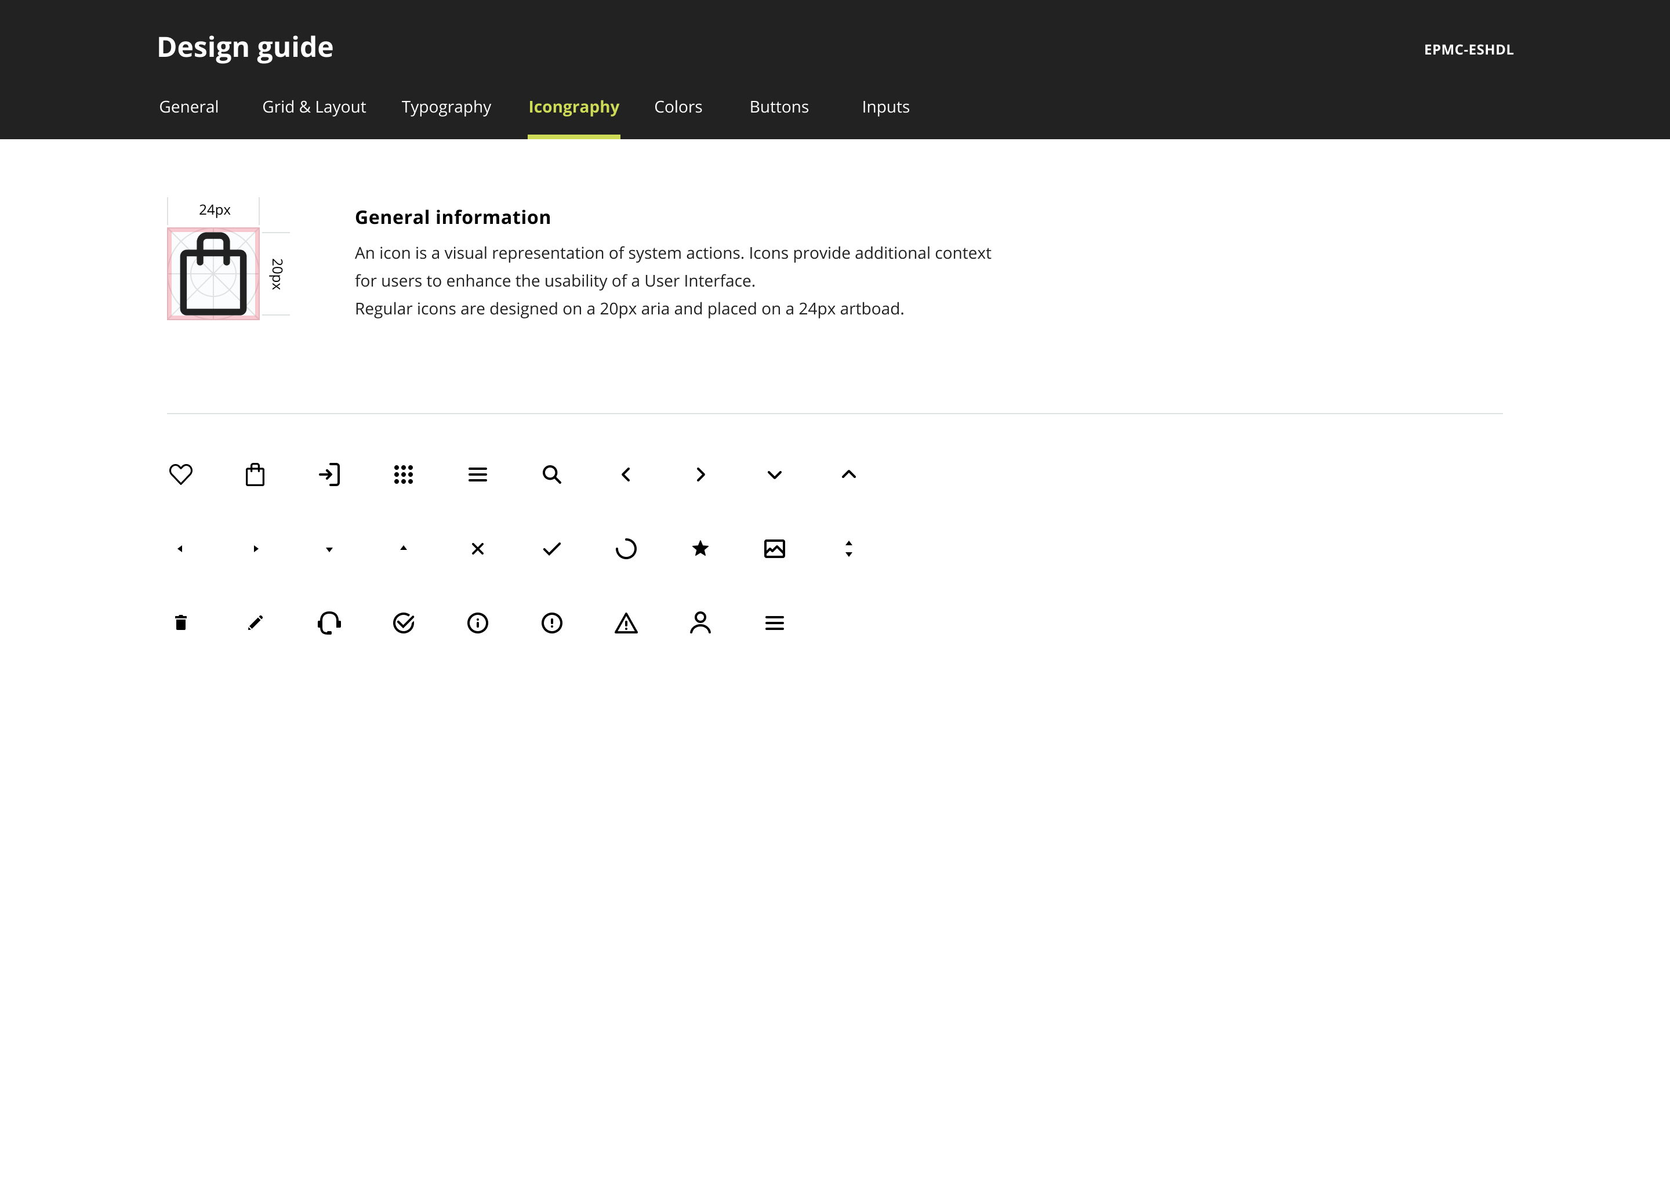

### 6.1.5 Inputs

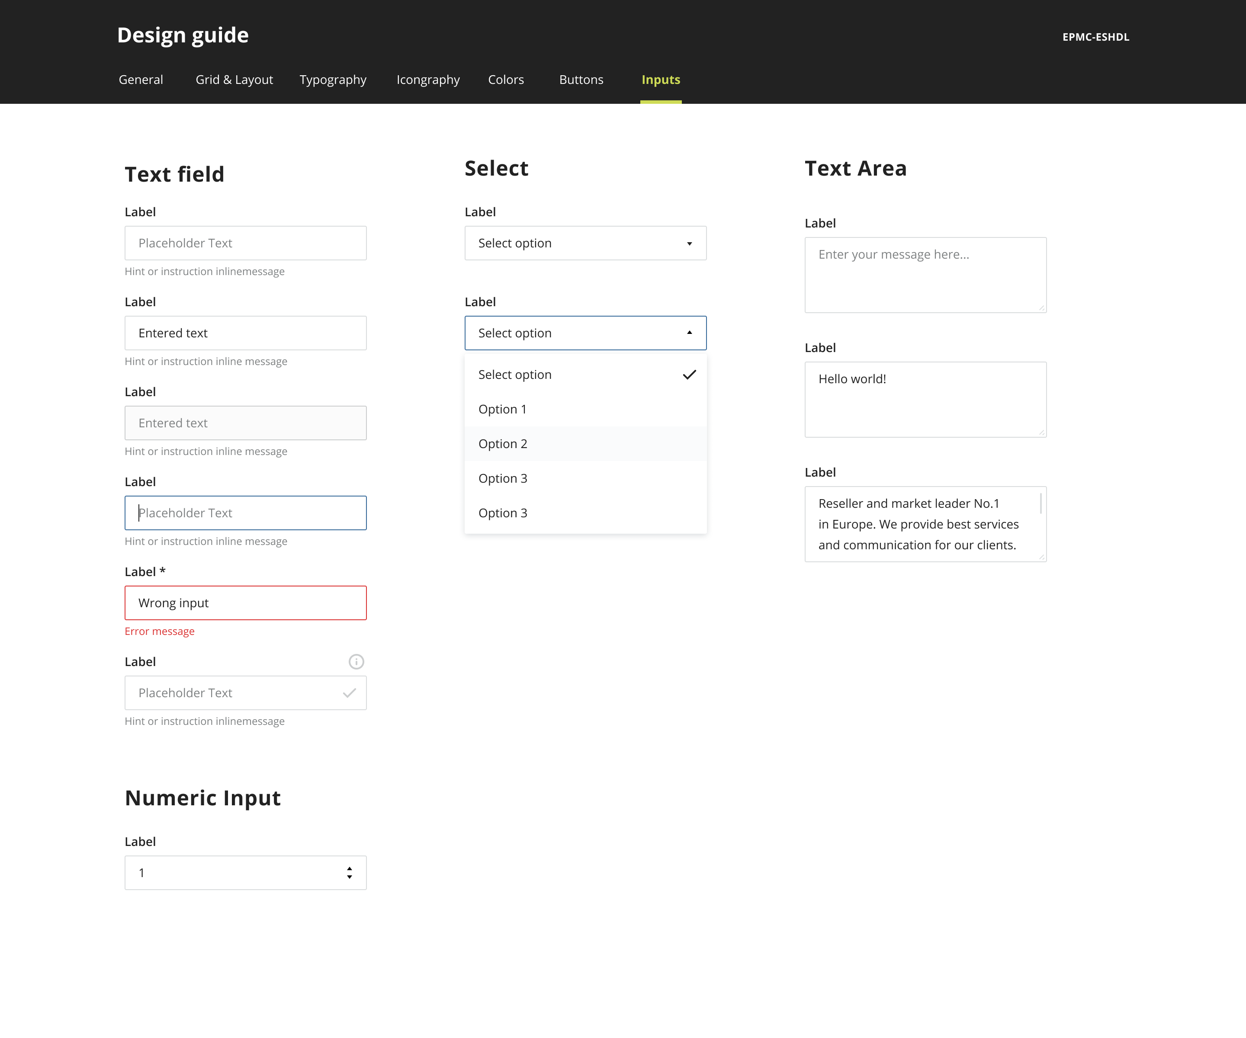

### 6.1.6 Typography System

Text is the main way to visualize information. The typography system includes font logical hierarchy and styles.

Hierarchy helps to keep consistency and readability through the website.

**Font family:** [Open Sans](https://fonts.google.com/specimen/Open+Sans)

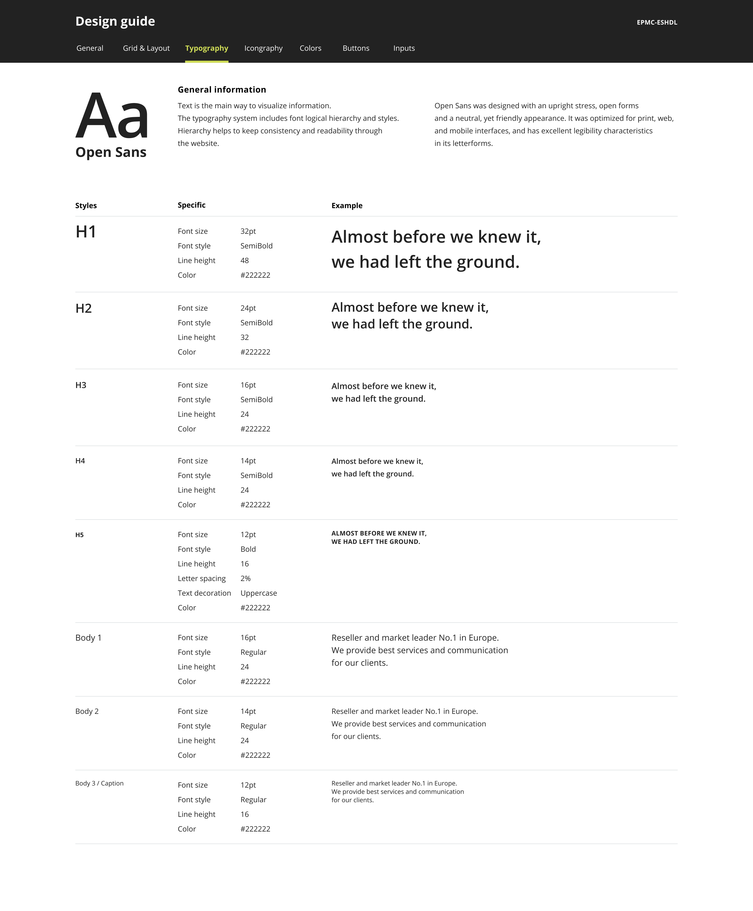

## 6.2 Mockups

### 6.2.1 Catalog / Search Results

|  |  |  |  |
| --- | --- | --- | --- |
|  | **Page Name** | **Description** | **Mockup** |
| 1 | Product List | Products per page: 12; All filters opened by default (can be adjusted: depends on needs); Pagination approach:<, 1-5, ... , last page, >;  OOS: Searching, Sorting, Changing view, Items per page feature |  |
| 2 | Search Results |  |  |
| 3 | No Results |  |  |

### 6.2.2 Checkout

|  |  |  |
| --- | --- | --- |
|  | **Page** | **Mockup** |
| 1 | Guest Checkout / Login |  |

|  |  |  |
| --- | --- | --- |
| 2 | Shipping Method |  |
| 3 | Billing and Payment |  |
| 4 | Add/Update Billing Address |  |
| 5 | Place Order (order overview) |  |
| 6 | Thank you page |  |

### 6.2.3 Login / Registration

|  |  |  |  |  |
| --- | --- | --- | --- | --- |
|  | **Page** | **Mockup** | | |
| 1 | Login |  | | |
| 2 | Registration |  |
| 3 | Restore Password |  | |

### 6.2.4 PDP

|  |  |  |
| --- | --- | --- |
|  | **Page** | **Mockup** |
| 1 | Product Details Full [Electronic Device] |  |
| 2 | PDP [Clothes example] |  |
| 3 | PDP / Size Chart |  |
| 4 | PDP / Bundle |  |

### 6.2.5 Shopping Cart

|  |  |  |
| --- | --- | --- |
|  | **Page** | **Mockup** |
| 1 | Shopping Cart Mini + Empty State |  |
| 2 | Shopping Cart with Bundle |  |
| 3 | Shopping Cart |  |
| 4 | Remove Product Modal Window |  |
| 5 | Edit Product Styles |  |
| 6 | Empty State |  |

### 6.2.6 Showcase

|  |  |  |
| --- | --- | --- |
|  | **Page** | **Mockup** |
| 1 | Showcase |  |